Liam Cui
CSCI: Homework 3

- NFA $δ=$
States | $$ε$$ | $$x$$ | $$f$$
$$∅$$ | $$∅$$ | $$∅$$ | $$∅$$
$$\{q_{0}\}$$ | $$\{q1\}$$ | $$\{q1, q2\}$$ | $$∅$$
$$\{q_{1}\}$$ | $$∅$$ | $$\{q_{0},q_{2}\}$$ | $$∅$$
$$\{q_{2}\}$$ | $$∅$$ | $$∅$$ | $$\{{q_{0},q}_{1}\}$$
$$\{q_{1},q_{2}\}$$ | $$∅$$ | $$\{q_{0},q_{2}\}$$ | $$\{{q_{0},q}_{1}\}$$
$$\{q_{0},q_{2}\}$$ | $$\{q_{1}\}$$ | $$\{q_{1},q_{2}\}$$ | $$\{{q_{0},q}_{1}\}$$
$$\{{q_{0},q}_{1}\}$$ | $$\{q_{1}\}$$ | $$\{q_{0}, q_{1},q_{2}\}$$ | $$∅$$
$$\{q_{0}, q_{1},q_{2}\}$$ | $$\{q_{1}\}$$ | $$\{q_{0}, q_{1},q_{2}\}$$ | $$\{{q_{0},q}_{1}\}$$

Calculating epsilon closure (Repeated states are crossed out)
States | E(States)
$$∅$$ | $$∅$$
$$\{q_{0}\}$$ | $\{q_{0},q_{1}\}$(new start)
$$\{q_{1}\}$$ | $$\{{∅,q}_{1}\}$$
$$\{q_{2}\}$$ | $$\{∅,q_{2}\}$$
$$\{q_{1},q_{2}\}$$ | $$\{∅,q_{1},q_{2}\}$$
$$\{q_{0},q_{2}\}$$ | $$\{q_{0},q_{1},q_{2}\}$$
$$\{{q_{0},q}_{1}\}$$ | $$\{{q_{0},q}_{1}\}$$
$$\{q_{0}, q_{1},q_{2}\}$$ | $$\{q_{0}, q_{1},q_{2}\}$$

New NFA using epsilon enclosures.
States | $$x$$ | $$f$$
$$*∅$$ | $$∅$$ | $$∅$$
$$*\{q_{0},q_{1}\}$$ | $$\{q_{0}, q_{1},q_{2}\}$$ | $$∅$$
$$\{{∅,q}_{1}\}$$ | $$\{∅,q_{0},q_{2}\}$$ | $$∅$$
$$\{∅,q_{2}\}$$ | $$∅$$ | $$\{{{∅,q}_{0},q}_{1}\}$$
$$\{∅,q_{1},q_{2}\}$$ | $$\{∅,q_{0},q_{2}\}$$ | $$\{{{∅,q}_{0},q}_{1}\}$$
$$*\{q_{0},q_{1},q_{2}\}$$ | $$\{q_{0}, q_{1},q_{2}\}$$ | $$\{{q_{0},q}_{1}\}$$
$$\{∅,q_{0},q_{2}\}$$ | $$\{∅,q_{1},q_{2}\}$$ | $$\{{{∅,q}_{0},q}_{1}\}$$
$$\{{{∅,q}_{0},q}_{1}\}$$ | $$\{{∅,q}_{0}, q_{1},q_{2}\}$$ | $$∅$$
$$\{{∅,q}_{0}, q_{1},q_{2}\}$$ | $$\{{∅,q}_{0}, q_{1},q_{2}\}$$ | $$\{{{∅,q}_{0},q}_{1}\}$$

DFA transition function and states created from keepers of {q0, q1} start.

DFA Q = q0, q1, q2

This was originally $\left\{q_{0},q_{1}\right\}, ∅, \{q_{0},q_{1},q_{2}\}$ respectively of the epsilon closure NFA.

DFA $δ=$
States | $$x$$ | $$f$$
$$q_{0}$$ | $$q_{2}$$ | $$q_{0}$$
$$q_{1}$$ | $$q_{1}$$ | $$q_{1}$$
$$q_{2}$$ | $$q_{2}$$ | $$q_{0}$$

F = $q_{1}, q_{2}$

$q_{0}=q_{0}$

$Σ=\{x, f\}$

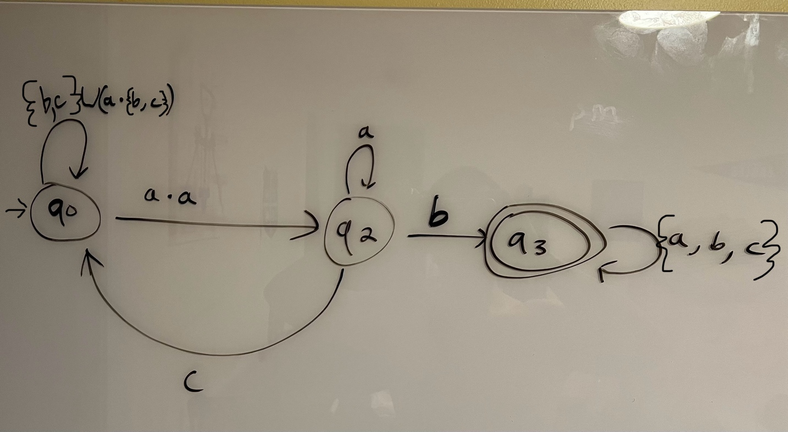
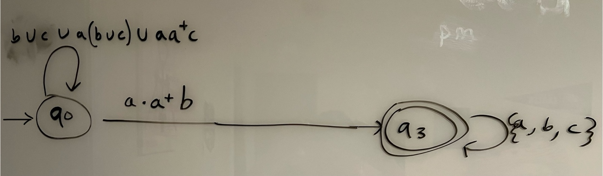
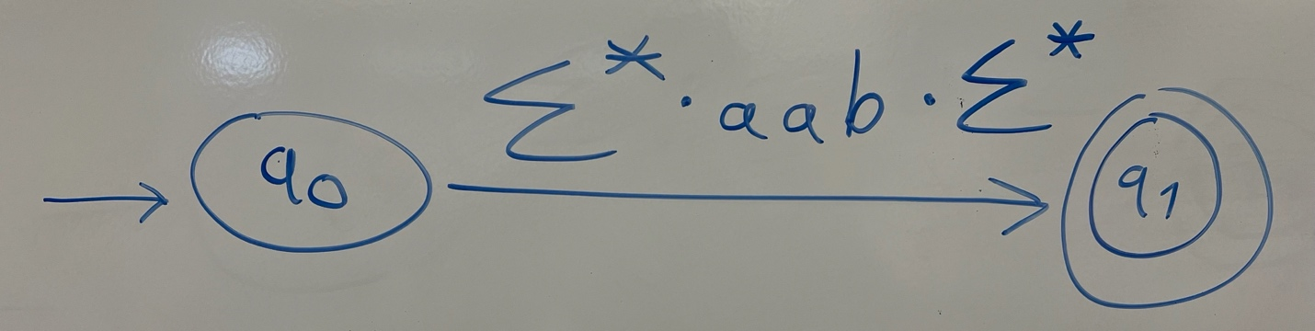The language of the GNFA uses the alphabet of {a, b, c} and is any string that contains the substring aab.

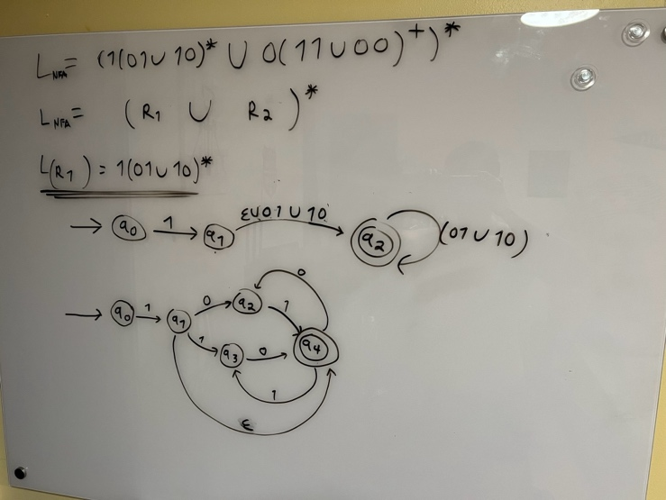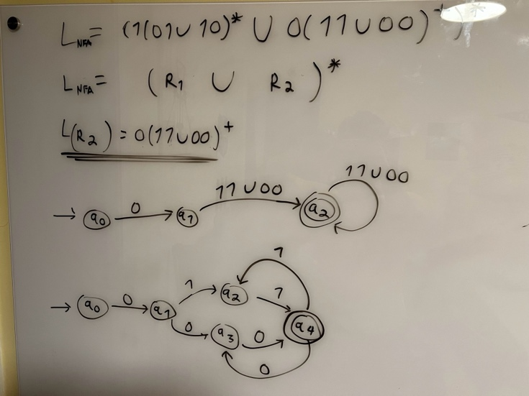
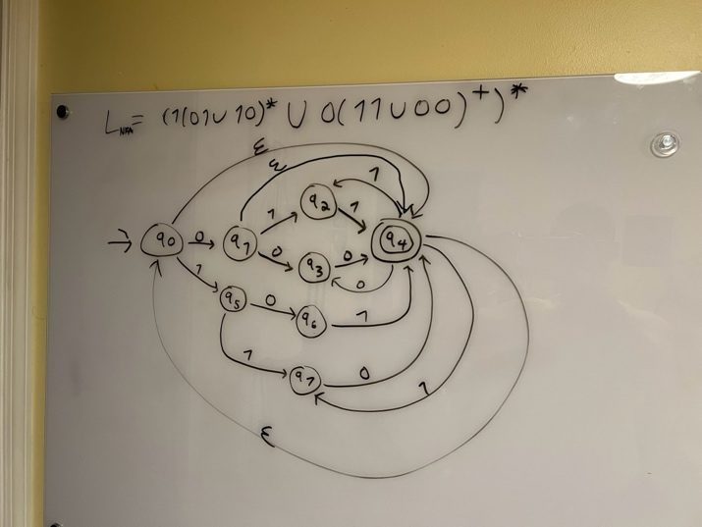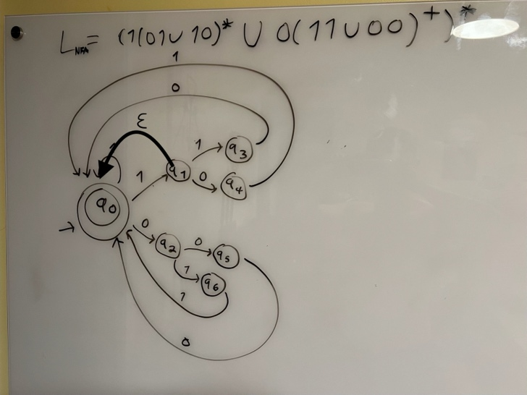

$$δ=$$
State | $$ε$$ | $$0$$ | $$1$$
$$q_{0}$$ | $$-$$ | $$q_{2}$$ | $$q_{1}$$
$$q_{1}$$ | $$q_{0}$$ | $$q_{4}$$ | $$q_{3}$$
$$q_{2}$$ | $$-$$ | $$q_{5}$$ | $$q_{6}$$
$$q_{3}$$ | $$-$$ | $$q_{0}$$ | $$-$$
$$q_{4}$$ | $$-$$ | $$-$$ | $$q_{0}$$
$$q_{5}$$ | $$-$$ | $$q_{0}$$ | $$-$$
$$q_{6}$$ | $$-$$ | $$-$$ | $$q_{0}$$
- $R=1\left(0∪1\right){(\left(0∪1\right)}^{2})^{*}∪0{(\left(0∪1\right)}^{2})^{*}$

$$Q=q_{0},q_{1},q_{2},q_{3}$$
$$Σ=\{0, 1\}$$
$$δ=$$
State | $$ε$$ | $$0$$ | $$1$$
$$q_{0}$$ | $$-$$ | $$q_{2}$$ | $$q_{1}$$
$$q_{1}$$ | $$-$$ | $$q_{3}$$ | $$q_{3}$$
$$q_{2}$$ | $$q_{3}$$ | $$q_{1}$$ | $$q_{1}$$
$$q_{3}$$ | $$-$$ | $$q_{1}$$ | $$q_{1}$$
$$F=q_{3}$$
$$q_{0}=q_{0}$$

- The least common multiple of 3 and 5 is 15. From this we know that both gears remain upright every 3 turns of G5. We also know that both remain in the upright position every 5 turns of G3. Therefore, it can be inferred that L2 can be represented with the regular expression $R_{2}={{(\left(ttttt\right)}^{*}∪{\left(fff\right)}^{*})}^{*}$. Because it can be represented with a regular expression it is a regular language.

- The least common multiple of 3, 5 and 7 is 105. Therefore, L3 can be represented with the regular expression $R_{3}={{(\left(t^{35}\right)}^{*}∪{\left(f^{21}\right)}^{*}∪{\left(s^{15}\right)}^{*})}^{*}$.

- If we remove the start state of N and instead use the original start state of N1 and have that be an accept state, then the language of N is no longer the $N_{1}^{*}$. This is because the removed start state had the purpose of redirecting epsilon towards a reject state. This is useful as N1 accepts epsilon and therefore by removing that reject state and modifying the N1 start state to be an accept state, we are now accepting string epsilon. This conflicts with the idea of $N_{1}^{*}$ as we have noted that epsilon is in N1.

